**Hands on – UDF and Stored Procedure**

**Hands on Name: Book The Show**

**Description:**

BookTheShow Corporation tells you to build an automated movie booking system so that they can track the movie details, the customer details and the movie tickets booked by the customers on respective movie complex. As the organization requires faster execution and better performance of the system, help the organization to achieve its objective using SQL Stored procedures/functions as appropriate.

**Schema Name: dbBookTheShow**

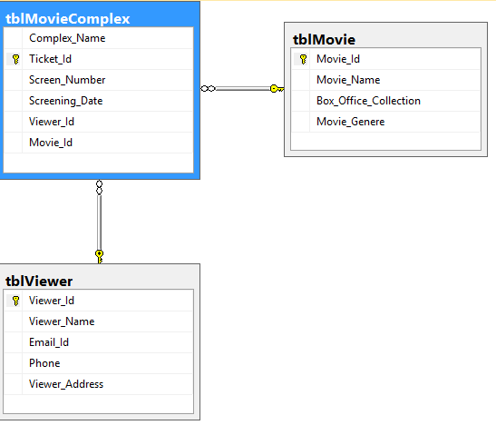

**Now based on the above schema and sample records solve the below queries:**

1. Create a Stored Procedure called uspUpdateMovieProc (@movieName varchar(100),@boxOfficeCollection varchar(100),@movieId varchar(100)) to update the movie name and box office collection from Movie Table through Movie Id. While updating data check if Id of the movie is present. If present update movie name and box office collection.

Execute the stored proc to test your code.

2. Create a Multi-Statement Table Valued Function fnDisplayMovieFunc() returns @movieData table(movie_genere varchar(100),movieCount int) to output the movie name and count of movies belong to each genere.

Run the function to test your code using Select statement.

3. Create a Inline Table Valued Function called fnDisplayViewBookingFunc (@genere varchar(100)) to display the viewer name, email, phone, complex name and screening date for the users who have booked movie which belongs to the genere supplied as function parameter. **[Note: The order of column for display should be same as given in question].**

Run the function using Select statement to test your output.

4. Create a Stored Procedure called uspDisplayMonthlyUserCountProc to display the month name and number of tickets booked in that specific month. [Give the count number an alias name called Monthly_Count].

Execute the stored procedure to test your query.

[Hint: Use Datename(month,column_name) to extract month from date value].

**[Note: The order of display is month name and then Monthly_Count]**

5. Now create a Stored Procedure as uspViewerTicketCountProc which displays the viewer name and ticket count booked by each viewer [Give alias Ticket_Count].

If a viewer has not booked any ticket display count as 0.

**[Note: The order of display is Viewer_Name and then Ticket_Count].**